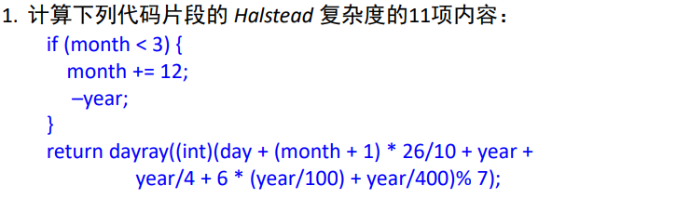

解答：

|  |  |  |  |
| --- | --- | --- | --- |
| Operator | Number of Occurrences | Operand | Number of Occurrences |
| if | 1 | month | 3 |
| < | 1 | year | 5 |
| += | 1 | day | 1 |
| - | 1 | 3 | 1 |
| return | 1 | 12 | 1 |
| + | 6 | 1 | 1 |
| * | 2 | 26 | 1 |
| / | 4 | 10 | 1 |
| % | 1 | 4 | 1 |
| dayray | 1 | 6 | 1 |
| int | 1 | 100 | 1 |
|  |  | 400 | 1 |
|  |  | 7 | 1 |
| n1 = 11 | N1 = 20 | n2 = 13 | N2 = 19 |

1.程序词汇表长度 Program vocabulary：n = n1 + n2 = 24

2.程序长度或简单长度 Program length：N = N1 + N2 = 39

3.程序的预测长度 Calculated program length：N^= $11\log_{2}{11}+13\log_{2}{13}$ = 86.16

4.程序体积或容量 Volume：V = $N\log_{2}{n}$ = $39\log_{2}{24}$ = 178.8

5.程序级别 Level：L^ = (2 / n1) * (n2 / N2) = 2/11 * 13/19 = $\frac{26}{209}$ = 0.124

6.程序难度 Difficulty：D = 1 / (L^) = $\frac{209}{26}$ = 8.04

7.编程工作量 Effort：E = V * D = $(\frac{8151}{26})\log_{2}{24}$ = 1437.39

8.语言级别：L’ = L^ * L^ * V = ${(\frac{26}{209})}^{2}*39\log_{2}{24}$ = 2.78

9.编程时间 (hours)：T^ = E / (S * f) = $\frac{1}{60*60*18}*(\frac{8151}{26})\log_{2}{24}$ = 0.022

10.平均语句大小：N/语句数 = $\frac{39}{4}$ = 9.75

11.程序中的错误数预测值：B = V/3000 = $(\frac{39}{3000})\log_{2}{24}$ = 0.06